
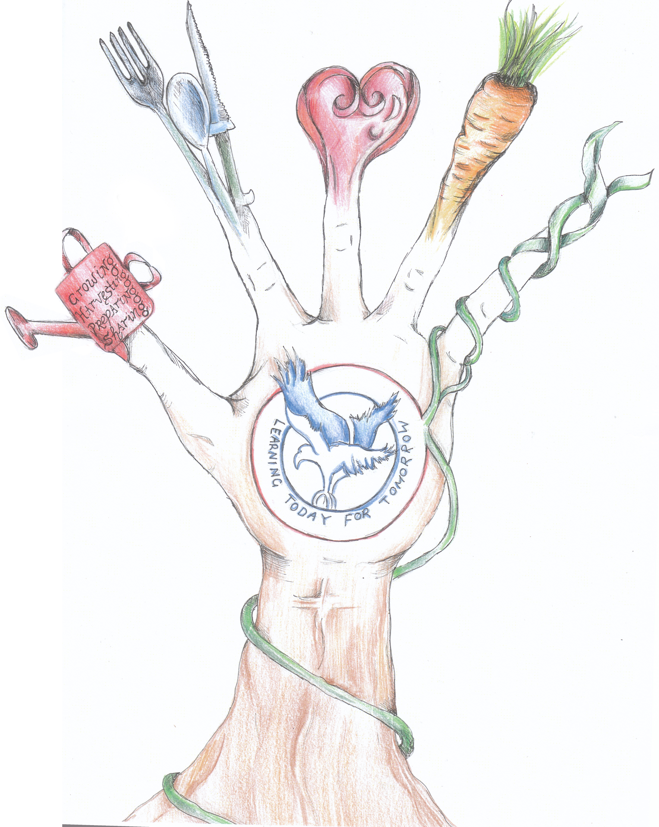
Kitchen & Garden Specialists for
Forster Public School
Kitchen Garden Program at Forster Public School

Growing Harvesting Preparing Sharing

On taking up position:

- Attend mandatory training and meetings when required
- Plan syllabus and facilitate 8-9 classes fortnightly with assistance of teacher
- Composing of permission notes and the collation of returned notes.
- Communicate any maintenance matters
- Raise awareness in the school community about the Kitchen Garden Program through the school newsletter and other avenues
- Liaise with the stage leader/s regarding planning issues;

Job description for Kitchen Specialist

Kitchen Garden at Forster Public School

- Plan the weekly menu, incorporating seasonal garden produce
- Pre-prepare elements of the menu if necessary
- Prepare recipes in a format suitable for children to understand
- Shop for extra ingredients within budget guidelines
- Maintain dry-food stores and monitor equipment needs and maintenance.
- Maintain a clean, hygienic learning space at all times
- Liaise weekly with the Garden Specialist
- Communicate harvest requirements to the Garden Specialist
- Liaise with the Garden Specialist about ways to integrate learning

