
Kitchen Specialist Job Description

Kitchen Garden Program at Weeden Heights Primary School (Vermont South)
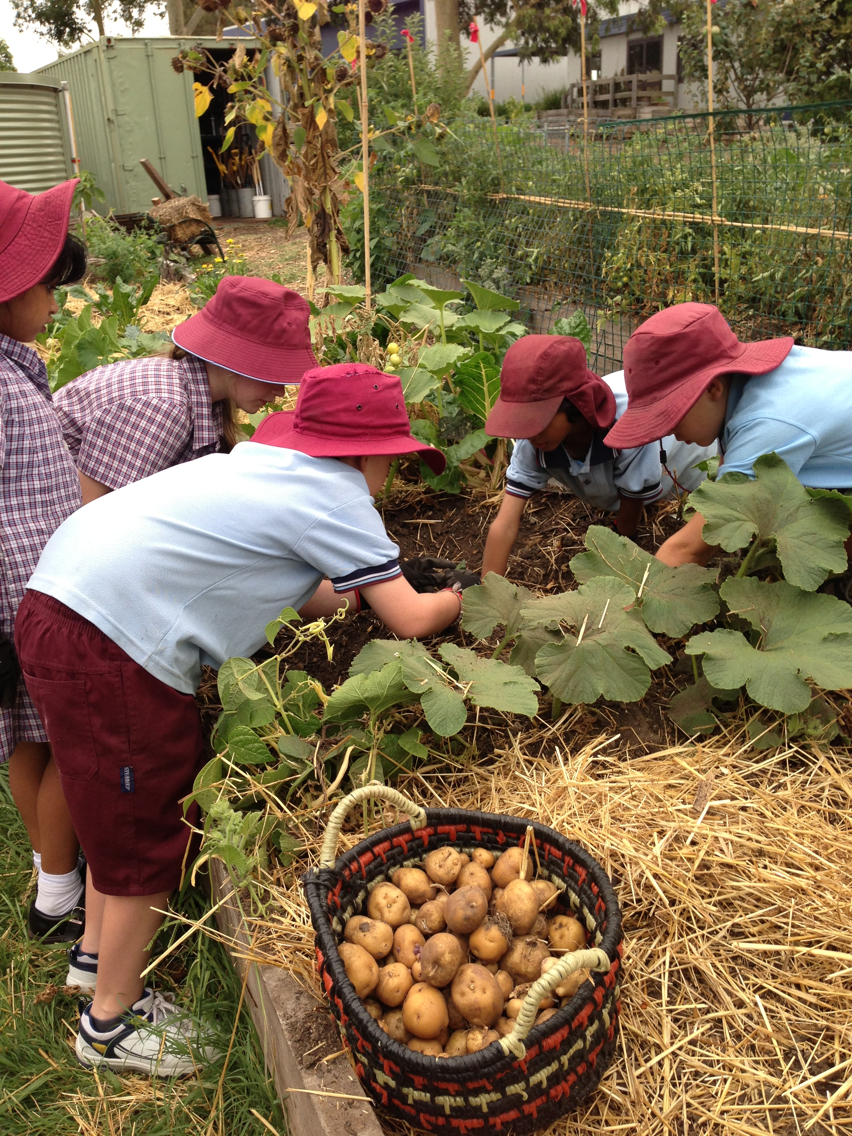
We are looking for an enthusiastic person to join our team and support the implementation of a dynamic and long-standing kitchen program that embeds our Science (environmental science and food technologies) curriculum, Student Wellbeing Program and Student Leadership Program.
Our Kitchen Garden Program is highly valued and well supported by our school community. We have strong links with the SAKG Foundation, Deakin University and the Whitehorse Community Volunteers.
The program’s mantra is ‘Growing, Harvesting, Preparing, Sharing’ and this supports the school’s philosophy of ‘Healthy Bodies and Healthy Minds’.
The aim of the Kitchen Garden Program is to introduce students to the wonderful world of good food by means of developing a productive food garden, and an exciting kitchen that includes a nurturing place to share food, as an integral part of the school curriculum. The program engages the curiosity of the students and supports them to make good food choices: to ensure they learn, grow the very best food in the very best way, how to care for a garden, how to recognise when food is ripe and at its best, how to prepare it easily and enjoyably and how to develop an expanding culinary palate and be excited by all of these experiences.
Classroom teachers are engaged and support you through the Kitchen and Garden sessions. Parents and the community are excited by the possibilities this Program offers.
On taking up the position you will:
- Liaise weekly with the Garden Specialist to incorporate the produce that is available from the garden in lessons and plan for future harvests in the upcoming kitchen sessions
- Communicate harvest requirements to the Garden Specialist
- Liaise with the Garden Specialist about ways to integrate learning in the kitchen with learning in the garden
- Plan the weekly menu, incorporating seasonal garden produce; and reinforce key techniques. Pre-prepare elements of the menu if necessary while briefing volunteers around session expectations
- Prepare recipes in a format suitable for students to read and understand. Arrange for recipes to be available for teaching staff prior to class and for learning within the actual session
- Shop for extra ingredients within budget guidelines
- Recruit, coordinate and support volunteers, help organise volunteer events, compile and update volunteer information, and respond to interest from potential volunteers
- Maintain dry-food stores and monitor equipment needs. Communicate any maintenance or replacement matters to the Business Manager or Principal
- Be resourceful about obtaining resources needed for the kitchen; actively seek and receive donations where possible
- Provide encouragement, advice and inspiration to other schools by facilitating group tours and school excursions to the kitchen garden, giving presentations and responding to phone calls and emails. Receive visitors to the kitchen and sometimes accommodate these visitors for lunch with the students
- Attend briefings with the Business Manager or Principal to participate in discussions on all aspects of the Program eg activities, special days, problem-solving
- Liaise with wider community and nurture relationships with those donating goods to the Kitchen Garden Program
- Assist with documentation of the project by recording comments on every class and storing menus, worksheets and student feedback eg class surveys
- Raise awareness in the school community about the Kitchen Garden Program through the fortnightly newsletter and the school based phone app
- Raise funds for the project by helping coordinate the sale of homemade preserves at the school market and spring fair
- Liaise with the level coordinators of the 5/6 team and 3/4 team regarding planning issues
- Liaise with the SAKG Co-ordinator re: weekly cleaning of the kitchen.

For any general enquiries for the kitchen position, please contact the school on 9802 0663.
The position will commence for the beginning of term 2 (Week commencing 19 April 2021) and the position is for one 6 hour day per week.

Applicants, please send your CV to:
Kylie Campbell
(Principal)
weeden.heights.ps@education.vic.gov.au

Applications close: 19 March 2021

